Add cover Add comment

**Filling The Numbers**

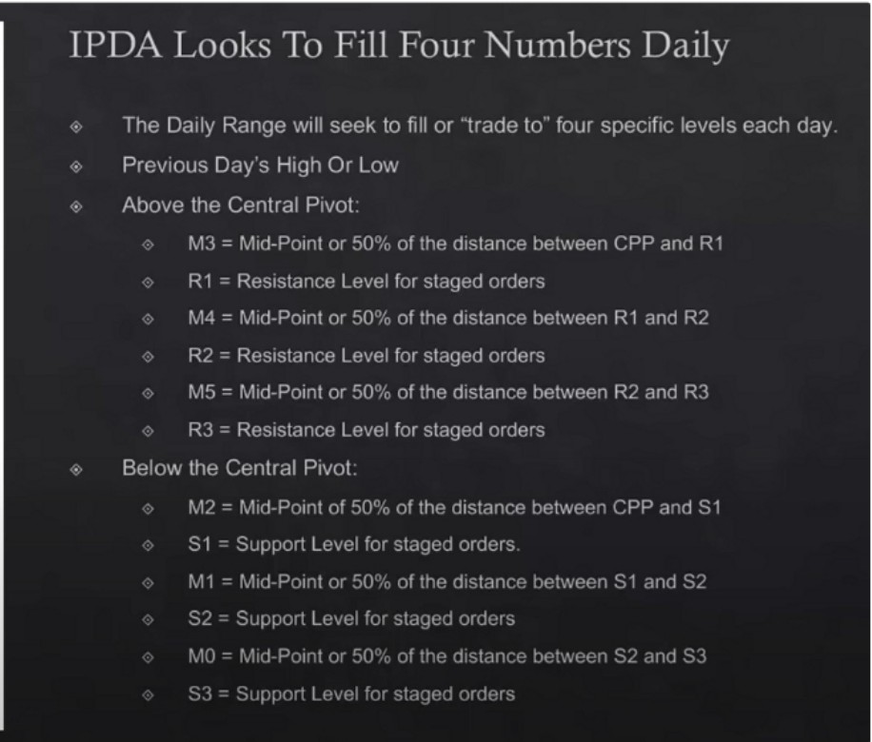

**Previous Day High R3**

**MS R2 M4 RI M3**

**Central Pivot M2**

**SI**

**Ml S2 MO S3**

**Previous Day Low**

As a daytrader were going to work with the previous day's high and low and the last 3 day's high and low, swing points on the daily chart

Funds and retail use pivot numbers

Look for central pivot points, 0 GMT pivots

Staged orders are from the funds, and because funds use these pivot points IPDA will likely trade to them and trough them. Staged meanse there are buyers and sellers at those levels because most people dont know how to use them

So what would otherwise be a good buy point and for example S1 or S2, it could be a good sell point for us once the daily range is expanding lower

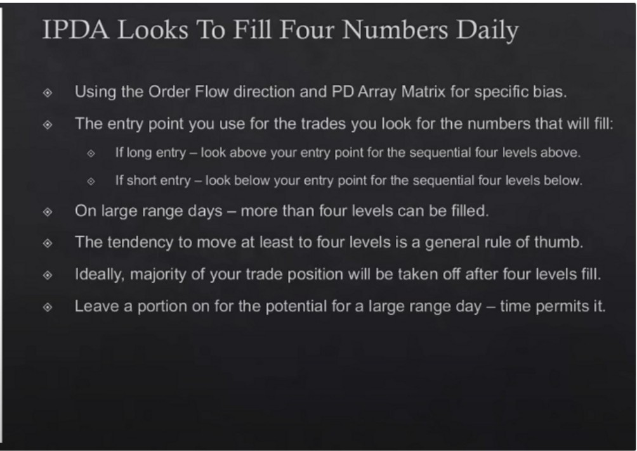

**Previous Day High R3**

**MS R2 M4**

**Rl**

**M3**

**Central Pivot M2**

**Sl Ml S2 MO S3**

**Previous Day Low**

If we look to go short, and we happen to short near R2 level then we can look for M4 R1 M3 and central pivot

Take 75% off to see if there will be a larger range day

**IPDA Looks To Fill Four Numbers Daily**

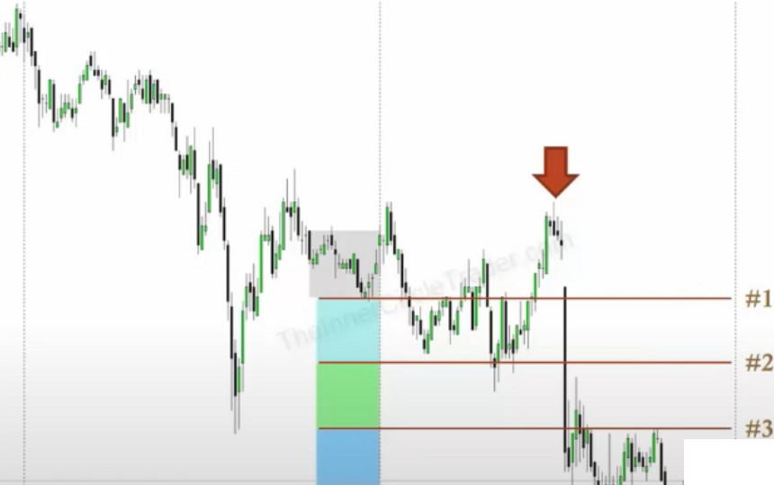

- --#4

·--=·-=---=-·-=-·-=-·=--·=--=·--=·--=·--=·--=·-=-·- ............................................,...........

Using the Order Flow d1rect1on and PD Array Matrix for specific bias

UtiliL1ng the CBDR when you are shorting tt1e market - Selling above the CBDR you count the Low uf the CBDR as level One of Four to fill

Expect the market to trade down to four CBDR Lows - *sec* chart the left

* Reverse for Buying

**IPDA is looking to fill 4 pivot points intraday and 4 CBDR points, either can be used**

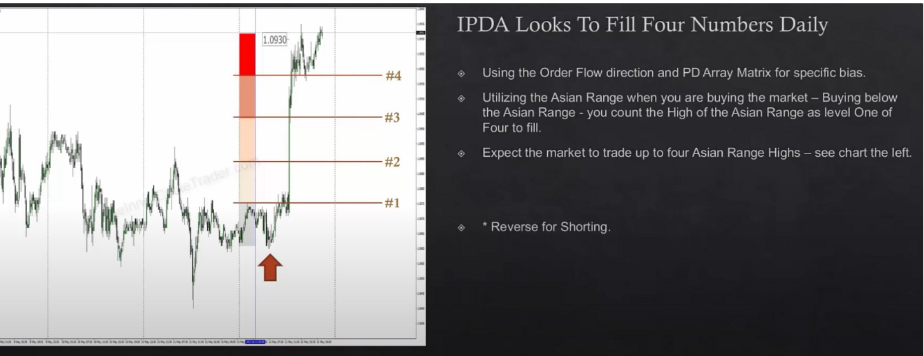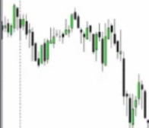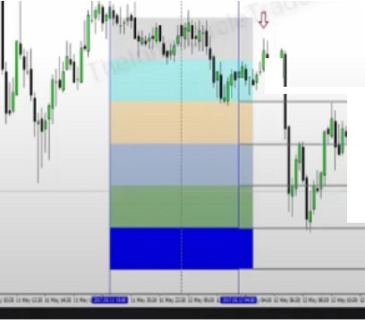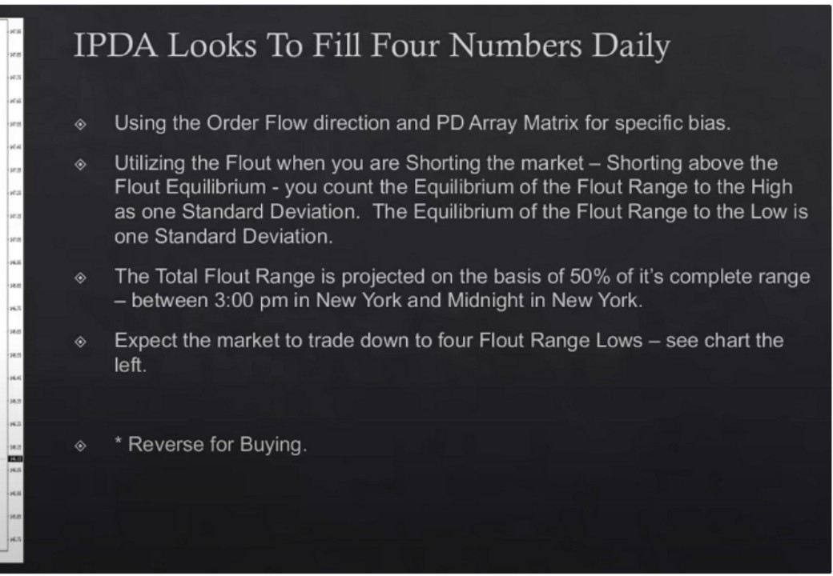

**jt**

**11**

\ I:

\ **12**

**Sell short above the EQ of the flout**

**4 is just a general rule of thumb, it can go lower or higher**

Which Numbers Do You Focus 0n7



**1**

**2**

**3**

**4**

**London Close**



**Time Of Day**

When considering which ··Numbers to fill - consider the fact that we do no ever know for certain which levels IPDA will use before the Trading Day begins

We ccin get closer to the truth .1s the tr;1d1ng d;iy completes

The New York Session will generr1lly provide the rnensurenients IPDA is presently using for Uic engineering of the Oc11ly Rc1ngc

',Vl! looh. for cor1fll1(\flU:s tJt;('.',Cl:I' OIH! er fHJ'-iSitJly llHHf! of HH: t()Ols., 'Nt! rllC,le>lH<'

*1(H* the fr_1,1• Cc1u;1l1r1q the-:;e 1'.1tt 1--·eser1t '';1d1111i c11.1rrHHTl!_'r1'. t1r11P,11

,Li·, '1,1·1,Hl•i f'D,\rr,J', r.L1'.11x 'IL, '.',1'1 D,11:•,- H1-:;I· I

By itself, these projections dont mean anything

If price is respecting a daily or 4h premium array, we're going to anticipate price rallying up at MNO or a bit after, that rally up is the judas swing. Then we use the projection to see how far it potentially can go and we couple it with an opposite PD array so in this case a daily or 4h discount array then look for it to line up with time of day and standard deviations

Eventually later in the day you can narrow down and know exactly where price is going to go

The worst case scenario is going to be that price will go further then you thought, thats why you leave a little piece on

Which Numbers Do You Focus On?



**Time Of Day**

**London Close**

**4**

**3**

**2**

**1**

When considering which Numbers to fill consider the fact that we do 110 ever know for certc=i1n wt71C:t1 levels IPDA will use before tt1e Trading Day begins

We can get closer to the truth as tt1e trading day completes

The New York Session will generc1lly provide the mec1surements IPDA 1s presently us1r1g for tt1c engineering of Uie Daily R,rngc

\1\'r· lnnk fnr c:nnllt1f:rl•:'.ec. :-if \l.'>f:,-:11 nni: nr ['' mnrr: nf tt1r: \nol-..; *·:,r:* ll1f:,b\lrf• '(:r 1'1t• fc,tir C(:l,j•l1rhJ tl1t·si• :,1!1l P't•s.,1•111 tr,1d111,_1,•11·.1r,;111n,,11: !1111t•

* i-ri Pn r.1,1trt\ :,1111111,,i"k '.t11· 1kt"· n,-1 1,' l,

We go trough all of them, so the central pivot, CBDR, asian range and flout. All of them, we look at the bodies and the wicks, we have to take in account the wicks standard deviations as well as the bodies.

Look for the projections to overlap with time of day and with a premium array, thats how ICT gets the daily highs and lows

When ADR also overlaps then you got real high probability, we'll talk about ADR later this month Then you can get really precise about your entries and exits

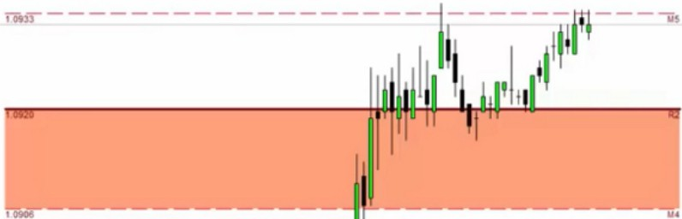

This was thursday where ICT expected the low of the week to be, it swept sell stops on the daily and intraday. It took out sell stops before the news at 830 thats likely going to be problematic and we're likely making the low of the week, thats forming the bullish orderblock on the chart example

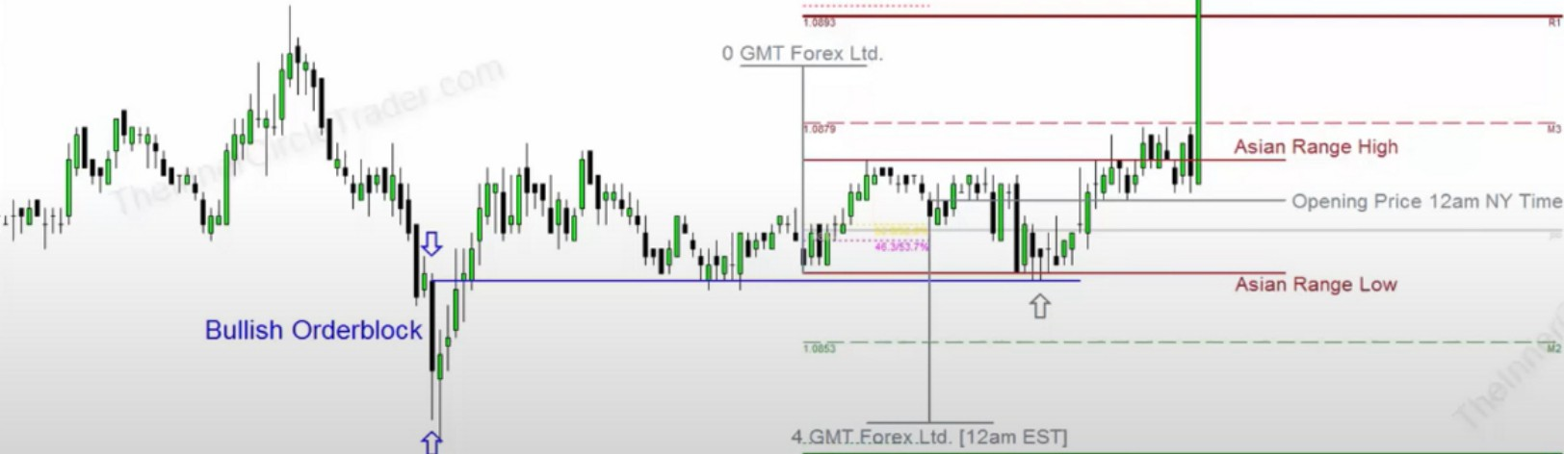

ICT said that we would probably see the high of the day at 1.0930 because there was a FVG at that price, what he didnt show was that he had all these projections on his chart as well

We want to get out ahead of price levels, we want to get out at the round numbers ahead of our target, so if we target 1.0933 then we want to get out at 1.0930

ICT doesnt use pivot points for entries

When we look to fill the numbers, we look for 4 of them, either pivot points, CBDR, asian range, or flout

It requires some effort, but youll get amazing results

If the markets do not move and theres no volatility then theres no precision, we need the market to be volatile

Arjo I Twitter, lnstagram I Linktree

Linktree. Make your link do more.

* https://t.co/HhmmTN1fUI

JavaScript is not available.

*"JI* https://twitter.com/arjoio